**Case Study – 5  
(50 points)**

**Name: Patrick Woodrum**

**Clemson ID: C79975506**

**Submission**: Save this Word document with your answers as a PDF file and upload the PDF file to Canvas.

Build a set of Data Flow Diagrams for the Book Exchange Project. Use one of the diagramming tools identified on the “External Tools Page” in Canvas.

* (10 pts) Context Diagram, Fig 5.11 & Fig 5.12
* (10 pts) Level 0 DFD, Fig 5.12 & Fig 5.13
* (10 pts) Level 1 DFDs (2 DFDs worth 5 pts each), Fig 5.14 & Fig 5.15

Context Diagram

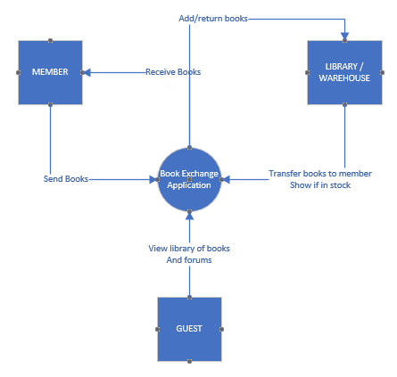

Level 0 DFD

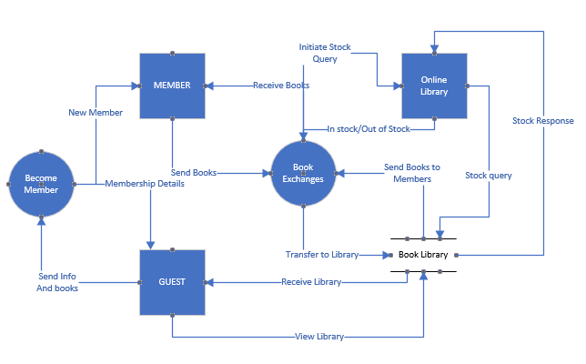

Level 1 DFD (1) For Becoming a Member Process

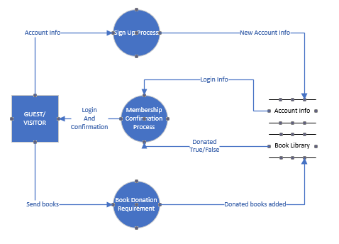

Level 1 DFD (2) For Book Exchanges Process

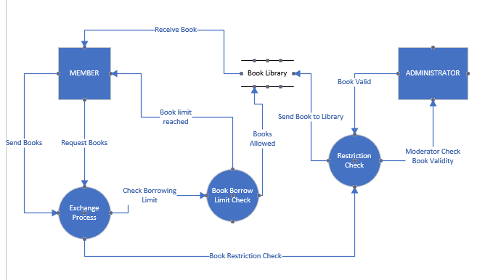

(10 pts) Build a Data Dictionary (Section 5.8, pp. 164-167) for the Book Exchange Project using Excel, documenting the Data Elements, the Data Flows, Data Stores, Processes, and External Entities based on your data flow diagrams above.

Data Elements

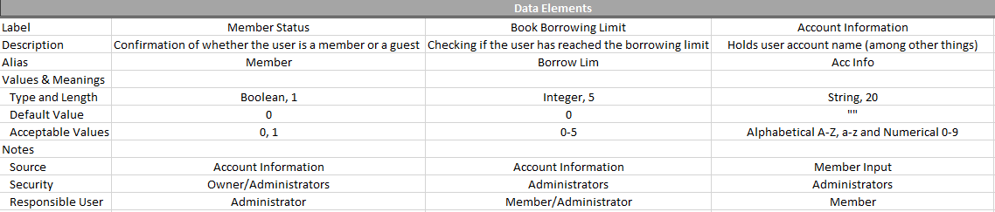

Data Flows

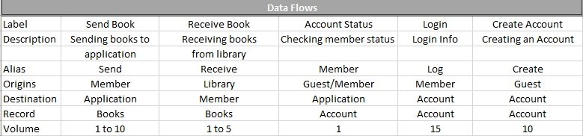

Data Stores

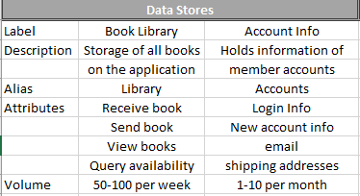

Processes

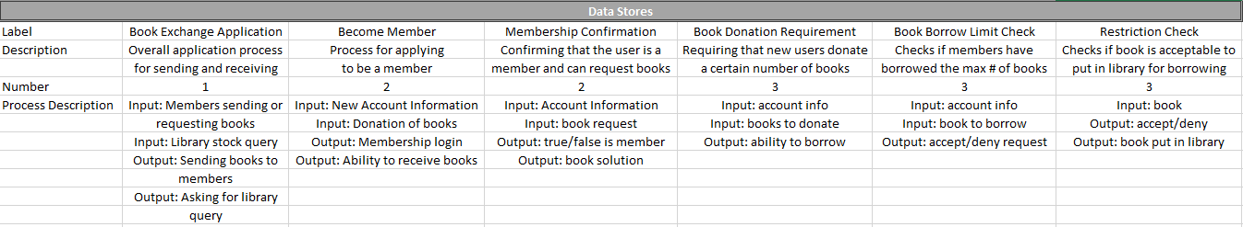

Entities

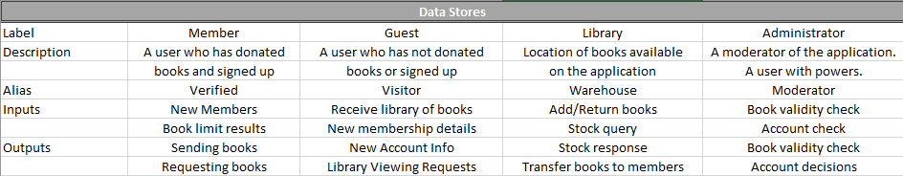

(10 pts) Build 2 Decision tables (Section 5.9.4 pp. 170-174) for the Book Exchange Project using Excel.  
One decision table must have at least 2 rules and another must have at least 3 rules.

2 Rules:

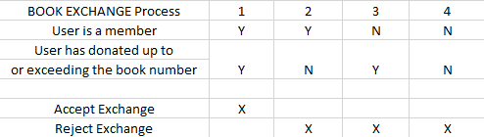

3 Rules:

